**Practical No:-** 09

**Roll No.:**15 **Batch-** A **Date of Performance:** 09/03/2024

1. **Write a PHP program for Serialization.**

<?php

$data=array("Samsung","Realme","Vivo","Lava","Redmi","Oppo");

echo "<b>Original Data=</b>";

foreach($data as $val)

{

echo $val.",";

}

$sdata=serialize($data);

echo "<br><br><b>Serialized Data=</b>".$sdata."<br>";

$udata=unserialize($sdata);

echo "<br><b>Unserialized Data=</b>";

var_dump($udata);

?>

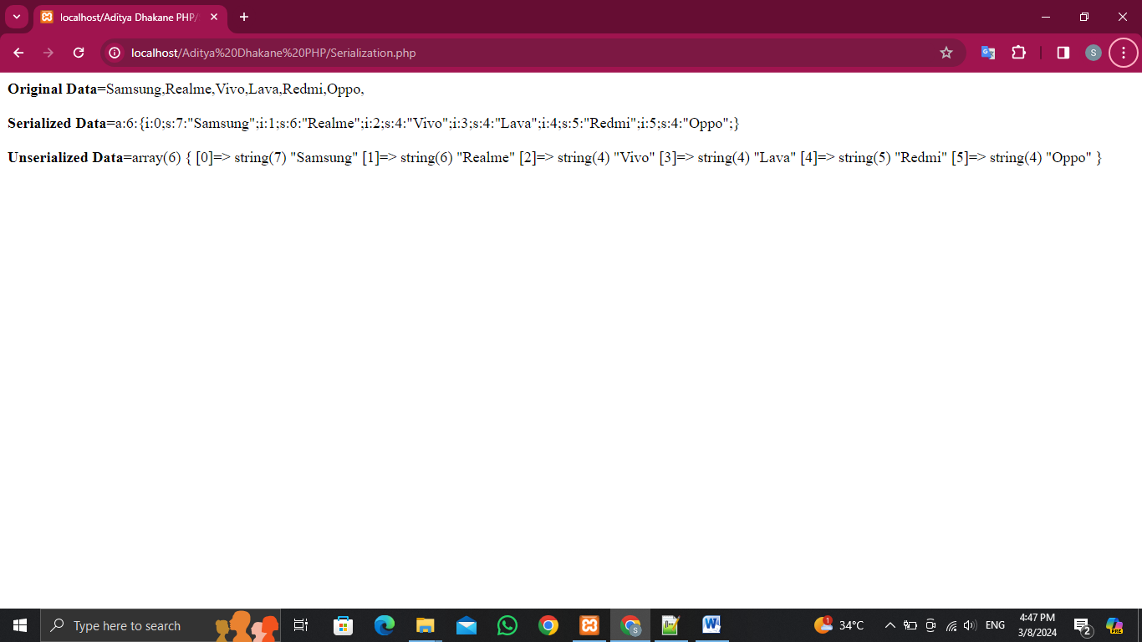

1. **Write a PHP program for Introspection.**

<?php

class Test

{

function hello()

{

echo "Hello Programmer<br>";

if (class_exists(get_parent_class($this))) {

echo get_parent_class($this) . " : I'm Super Class<br>";

}

}

}

class Sample extends Test

{

function bye()

{

if (is_subclass_of($this, "Test")) {

echo "I'm Sub Class of : " . get_parent_class($this);

}

echo "<br>Bye Programmer";

}

}

$o1 = new Sample();

$o1->hello();

if (method_exists($o1, 'bye')) {

$o1->bye();

}

?>

